18.73: a) To escape, the total energy must be positive, 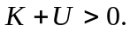 At the surface of the earth, 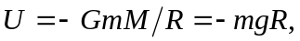 so to escape 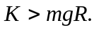 b) Setting the average kinetic energy equal to the expression found in part (a), For nitrogen, this is

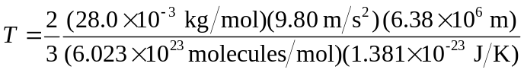

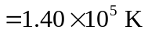

and for hydrogen the escape temperature is 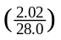 times this, or 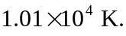 c) For nitrogen, 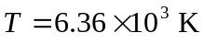 and for hydrogen, 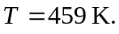 d) The escape temperature for hydrogen on the moon is comparable to the temperature of the moon, and so hydrogen would tend to escape until there would be none left. Although the escape temperature for nitrogen is higher than the moon’s temperature, nitrogen would escape, and continue to escape, until there would be none left.

